**Project Report On**



STUDY BOX

Submitted in partial fulfillment for the award of

**Diploma in Advance Computing(E-DAC) from C-DAC, ACTS (Pune)**

**Guided by:**

**Ms. Sarita**

Presented by

Arpit Tyagi PNR:210540181032

**Centre for Development of Advanced Computing (C-DAC), Pune**



**ACKNOWLEDGEMENT**

**This project “STUDY BOX” was a great learning experience for us and we are submitting this work to Advanced Computing Training School (CDAC ACTS).**

We are very glad to mention the name of *Ms. Sarita Mam*for her valuable guidance to work on this project. Her guidance and support helped us to overcome various obstacles and intricacies during project work.

We are highly grateful to *Ms. Risha P.R.* (Manager (ACTS training Centre), C-DAC, for her guidance and support whenever necessary while doing this course Diploma in Advanced Computing (E-DAC)through C-DAC ACTS,Pune.

Our heartfelt thanks go to *Ms. Swati Salunkhe*(Course Coordinator, E-*DAC*) who gave all the requiredsupportandkindcoordinationtoprovideallthenecessitiesandextrahourstocompletethe project and throughout the course up to the last day here in C-DAC ACTS,Pune.

**From:**

Mr. Arpit Tyagi (210540181032)

Contents

1. Introduction 4

2. Product Overview and Summary 5

2.1 Purpose: 5

2.2 Scope: 5

2.3 Overview: 5

2.4 FeasibilityStudy 5

3. OverallDescription 7

3.1 Product Features 7

3.2 Technology Used 7

3.3 User Classes 8

3.4 General Constraints 8

4. Requirements 9

4.1 Functional Requirements 9

4.2 User Interface Requirements 10

5. Design 11

5.1 Database Design: 11

5.2 Database Tables: 11

6. Testing 14

7. Project Management Methodology 15

8. Future Updates 15

# Introduction

We have developed an online portal website for CDAC for online training courses. This portal is named “STUDY BOX”. The portal serves as a single platform for students to access and manage all their learning requirementsat CDAC. Any candidate who wants to take training in latest technologies can visit this website and can view all the current courses available, can check modules that will be covered in a particular course, its syllabus along with the duration of a particular course. He/she can also register themselves for any course.

The platform displays and provides key information related to placements and list of companies that frequently visit our institute. User Interface developed using React libraries uses user email and password (captured during registration)to authenticate and data is imported using REST. UI makes secure calls to Spring Boot. In the backend, JAVA is used to fetch and manipulate the data whereas MySQL is used as database.

The Study Box is an application that allows login for student, faculty and admin. The Admin is responsible for managing student as well as faculty details. The platform enables Admin user to update, delete and fetch student details as well as faculty details. Admin can also add a faculty. The platform also provides facilities for making announcements, uploading files and marks.

A lot of API’s are utilized for the ease of user. For the login of users into this website we use the user email authentication, which allows users to sign up with their email. This platform is based on REST services, and it tends to work independently of all services which in turn improves the efficiency of the tool.

# Product Overview and Summary

## 2.1 Purpose:

Taking online training is not easy if the platform is not managed well. Students face problems with the management of course like getting class in different platform, uploading assignments in different platform, getting updates related to class and all, in different platforms and so on.We need an online portal website where candidate can view all available courses with modules and syllabus. Register themselves and in one single platform, student has access to all the activities which are related to that course.

## 2.2 Scope:

With the pandemic hit, online education became necessity for students. This portal will provide

online training education.

## 2.3 Overview:

Section 3.0, the Overall Description, provides an overview of the components and the relationship between them. Section 4.0 provides the Specific Requirements of the product. In the subsection (4.1) and (4.2) of which the various functional requirements and various interface respectively are discussed. Section 5.0 describes Database Designdetails.

## 2.4 FeasibilityStudy

Feasibility is determination of whether a projects worth doing or not. Before recommending the new system, it is important to investigate if it is feasible to develop the new system.

Beforedevelopingandimplementingasystem wehavesurethatoursystemisfeasible in the followingways:

1. Technical Feasibility
2. Operational Feasibility

* **TechnicalFeasibility**

In the type of feasibility study, the system analyst has to check whether it is possible or not to develop the requested system with availability of manpower, software, hardware, etc.The systemwhichweruninwindowsplatformandhencearesuitablefortheend- user. The system is technically feasible because it does not require too many resources and runs with the browser. A proof of concept was implemented to verify the technical feasibility to retrieve data from variousAPIs.

* **Operational Feasibility**

In this type of feasibility study the operation implementation of the system is considered. Checking is done regarding whether it is feasible for the users to use the application. Thus, the proposed system is said to be operationally feasible only of the end users are able to understand the system clearly and correctly and can use the system with ease and with the minimum training.

# OverallDescription

## Product Features

The project's aim is to provide a use friendly platform for students and admin for managing online training programs for an institute, which is containing java (platform independent), React, API’s for user.

## Technology Used

BACKEND

Spring Boot + Spring Data JPA.

MYSQL for storage of data.

FRONT END

React CSS

Platform:

Web Development: J2EE Spring Boot, React, MySQL J2EE Spring Boot

Spring Boot has been built for Rapid Application Development. The goal of Spring Boot is to

provide a way to create Java applications quickly and simply, through an embedded server. By default, it used an embedded version of Tomcat and hence eliminating the need of Java EE containers.

It is a framework to ease the bootstrapping and development of new Spring Applications. Bootstrapping with defaults included in the configuration/ jar-dependencies. Easy to create standaloneapplications withembeddedTomcat/Jetty/Undertow.Itprovidesdefaultsforcode and annotation configuration to quick start new spring projects within no time. Plenty of Spring Boot Starter to quickly get up andrunning.

Nocodegeneration andnorequirementforXMLconfiguration.Itreduceslotsofdevelopment time and increasesproductivity.

React

React is a JavaScript library for building user interfaces. It has transformed the way we think about front-end development. React.js has clasped the engagement of the open-source community. And its demand is irreversible in the coming future. It is here to stay.

Improved performance: React uses Virtual DOM, thereby creating web applications faster. Virtual DOM compares the components’ previous states and updates only the items in the Real DOM that were changed, instead of updating all of the components again, as conventional web applications do.

MySQL

MySQL is an open-source relational database management system (RDBMS). A list of commonly used MySQL queries to create database, use database, createtable, insert record, update record, delete record, select record, truncate table and drop table etc. MySQL is a relational database management system based on SQL – Structured Query Language. The application is used for a wide range of purposes, including data warehousing, e-commerce, and logging applications.

The most common use for MySQL, however, is for the purpose of a web database. It can be used to store anything from a single record of information to an entire inventory of available productsforanonlinestore.InassociationwithascriptinglanguagesuchasPHPorPerl(both offered on our hosting accounts) it is possible to create websites which will interact in real- time with a MySQL database to rapidly display categorized and searchable information to a websiteuser.

## User Classes

There is two type of user which can access this website. One is STUDENT and the second one is ADMIN which will manage the students and faculty.

## General Constraints

Users should have an email and have a browser

# Requirements

## FunctionalRequirements

**4.1.1 CompleteSystem:**

ADMIN Functionalities:

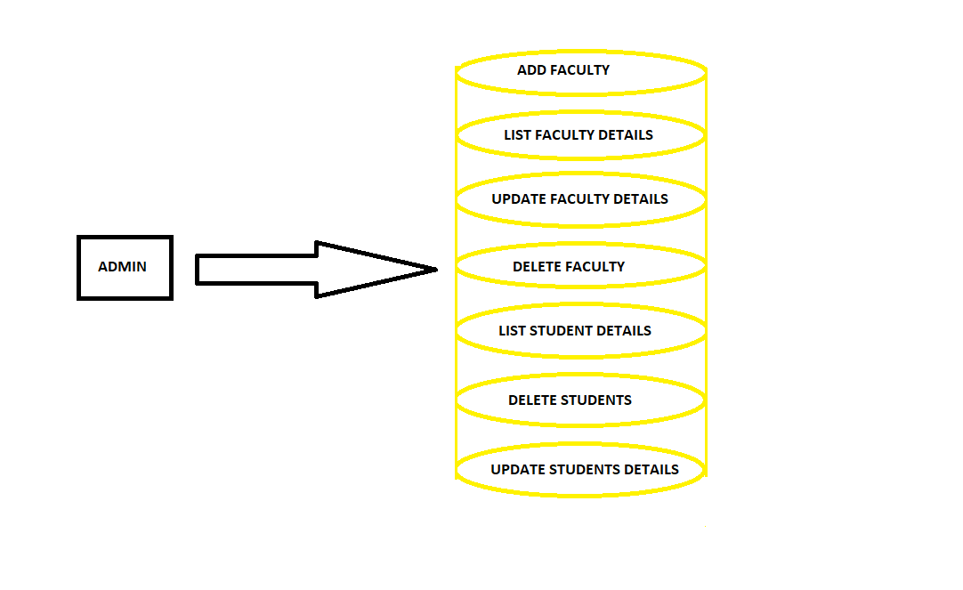

Registration Form:

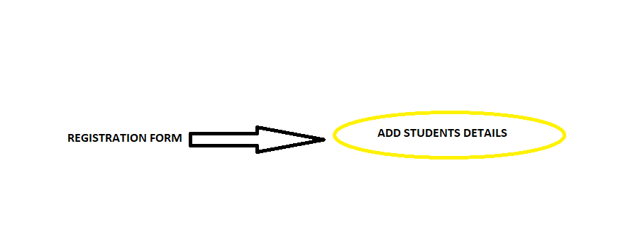

STUDENT FUNCTIONALITIES:

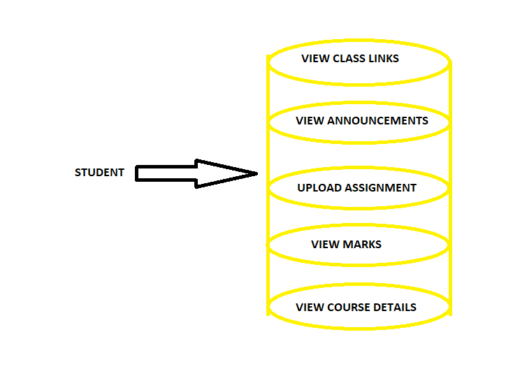

## User Interface Requirements

### Web pages screenshots:

### Home page

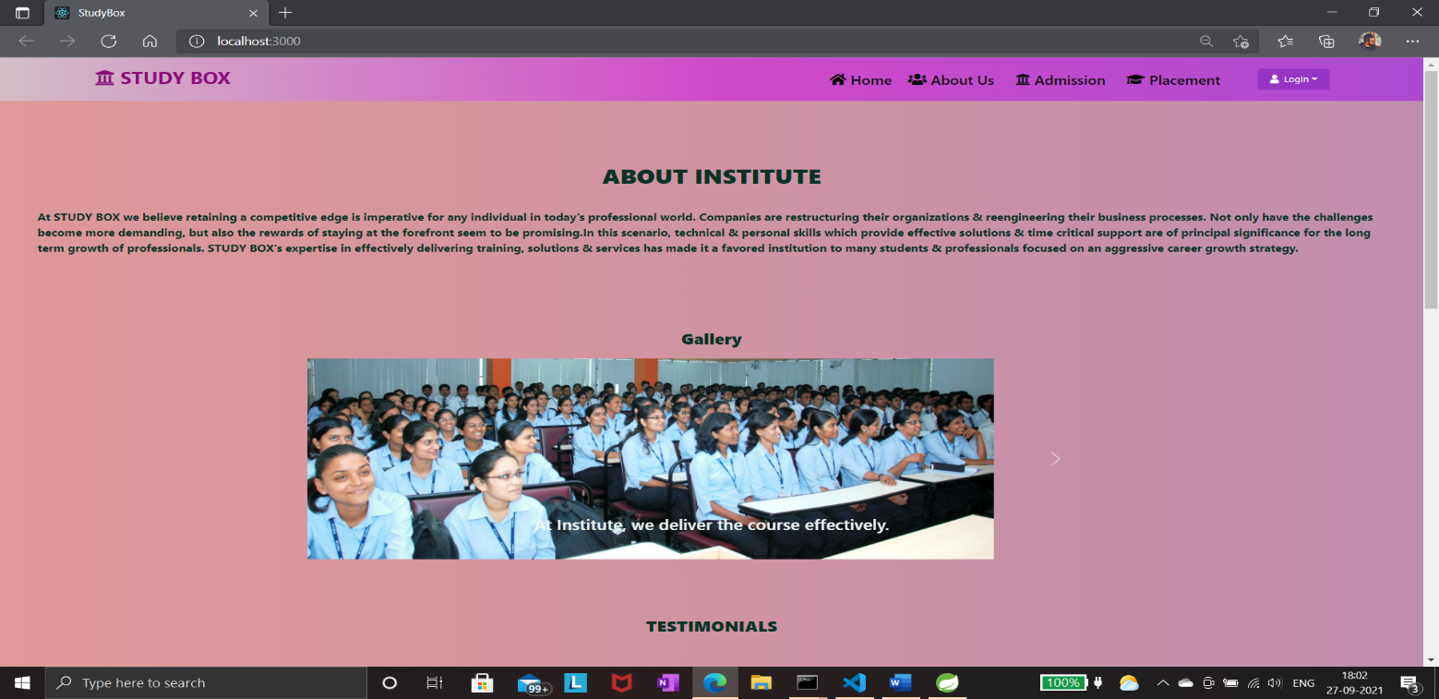

1. About Us Page

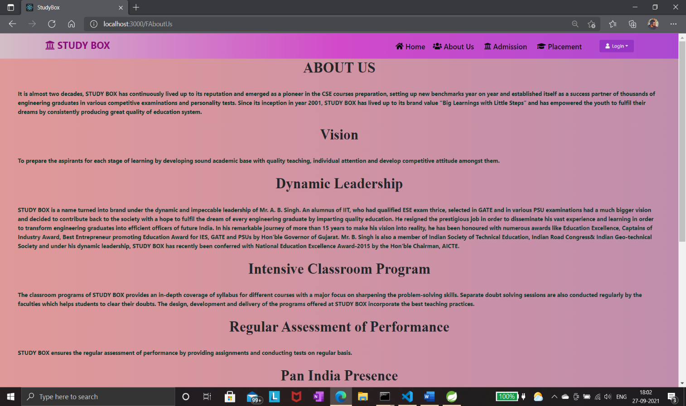

### 3. Admission

### 3.1 Course Details

### 3.1.1 DAC

### 

### 3.1.2 DAI

### 

**3.2 Registration Form**

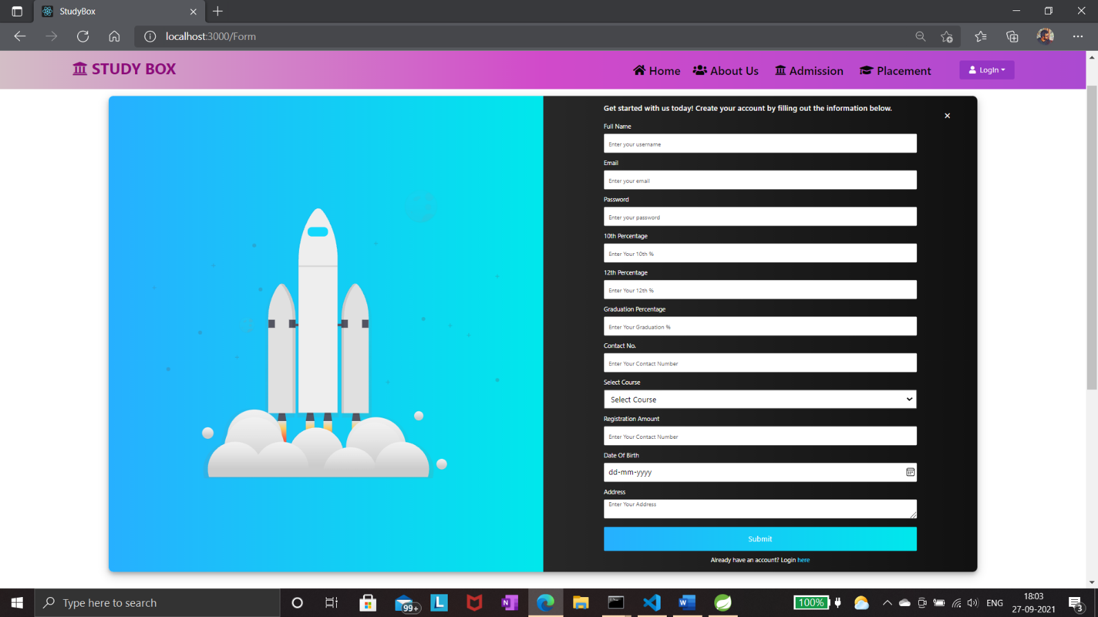

**4. Placement Page**

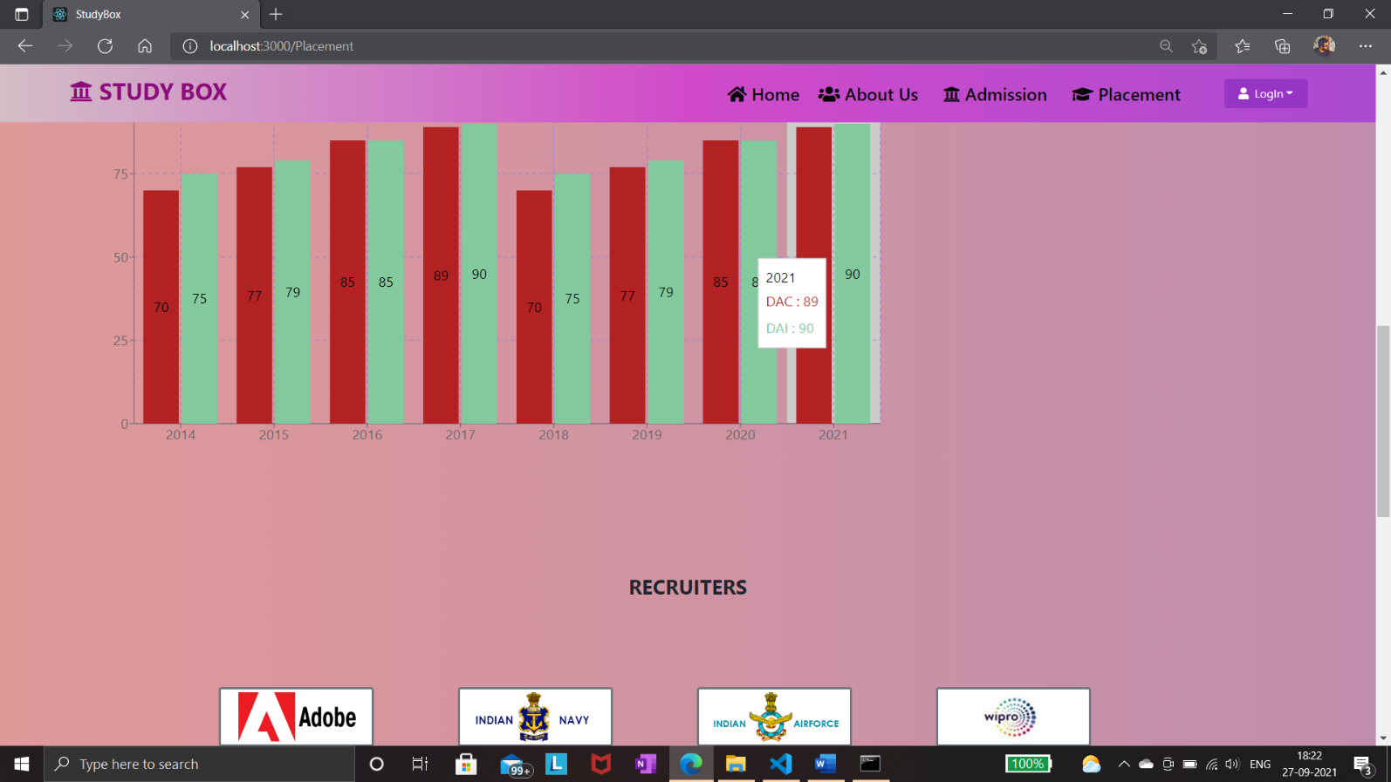

**5. Login Page**

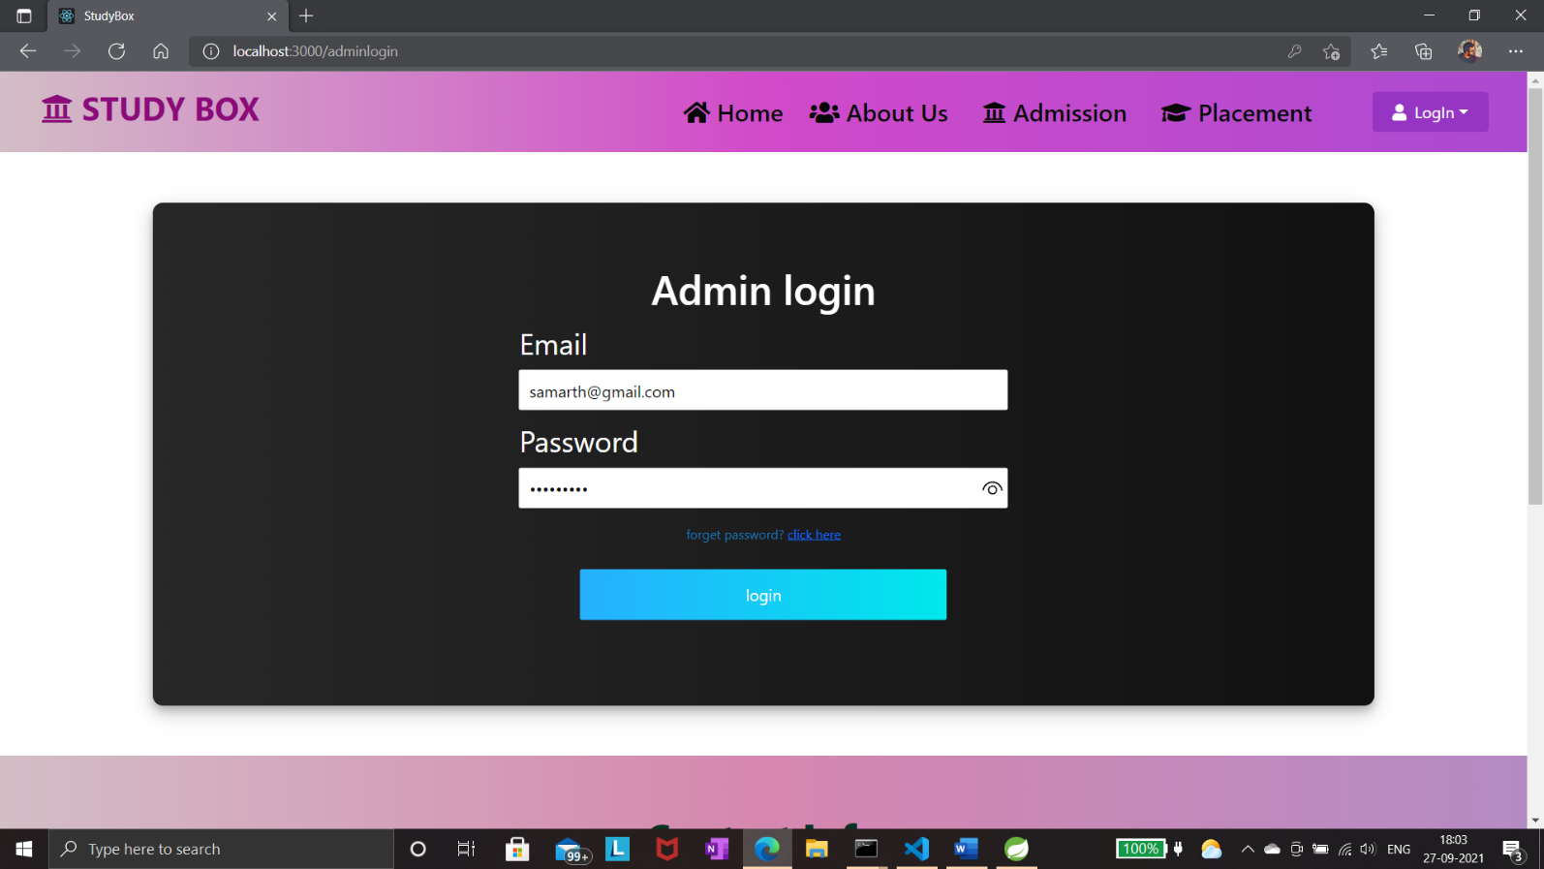

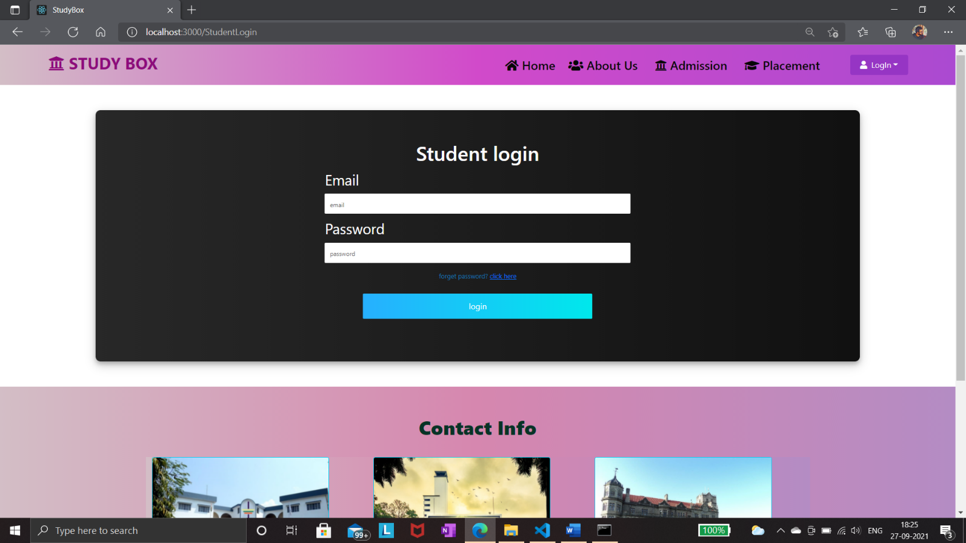

**6. Admin Home Page after successful login**

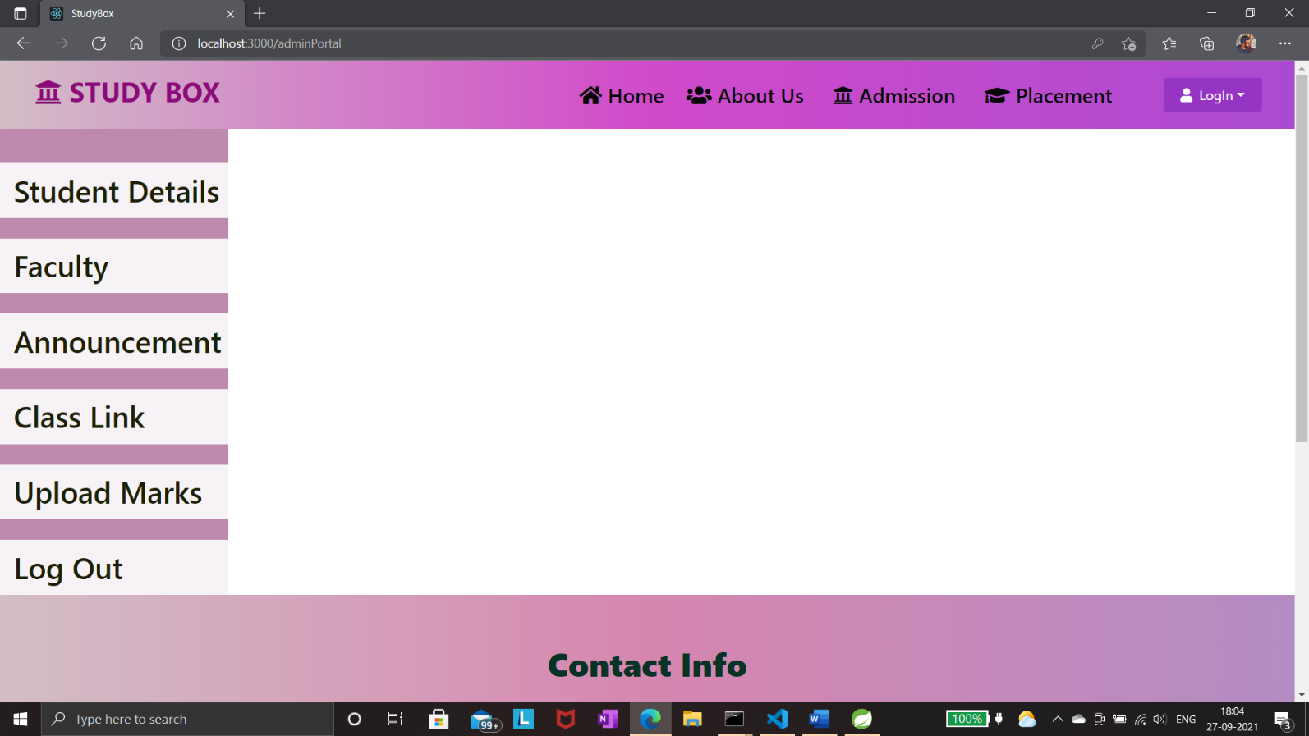

**7. Student Home Page after successful login**

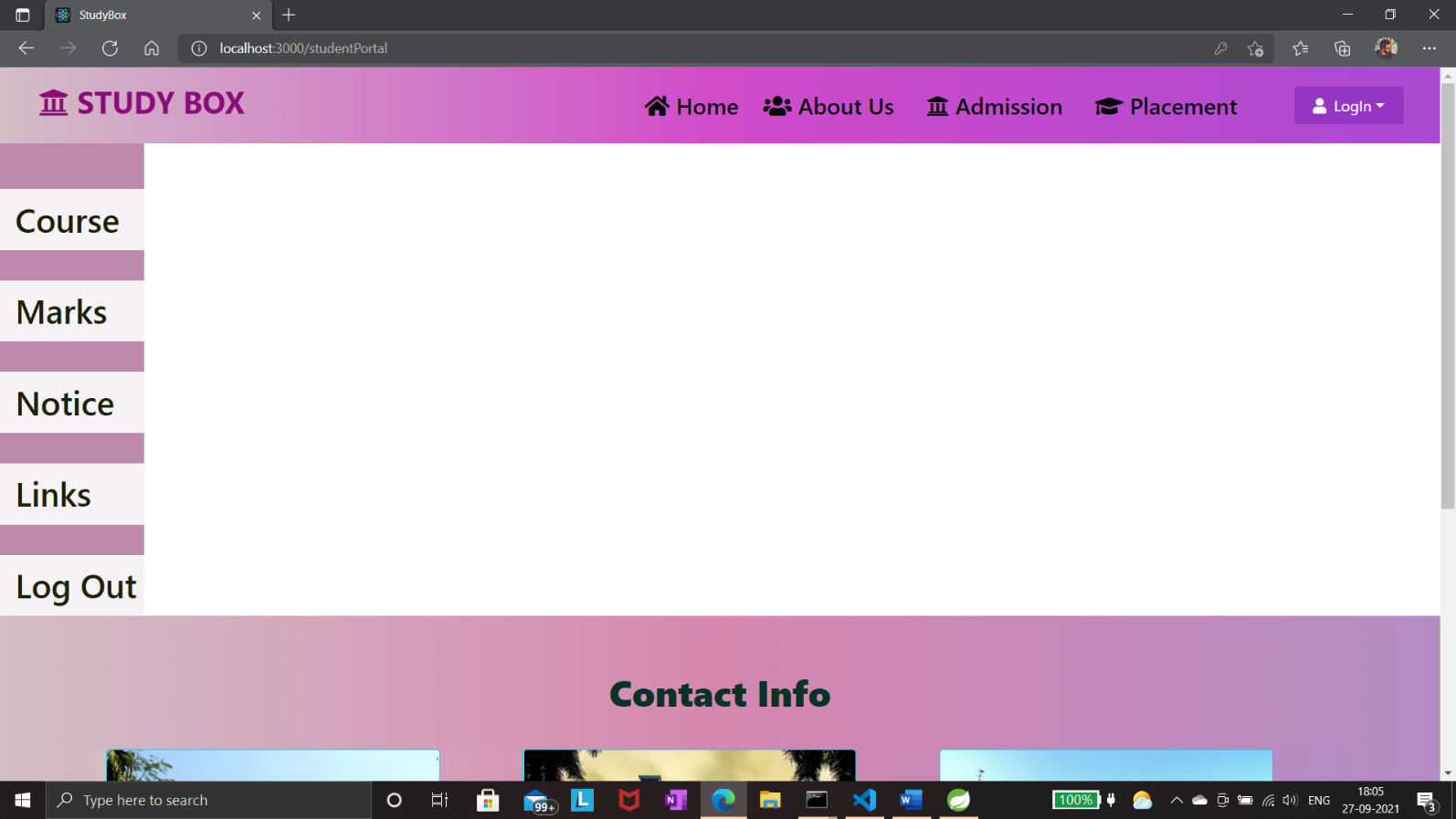

# Design

## 5.1 Database Design:

ER DIAGRAM

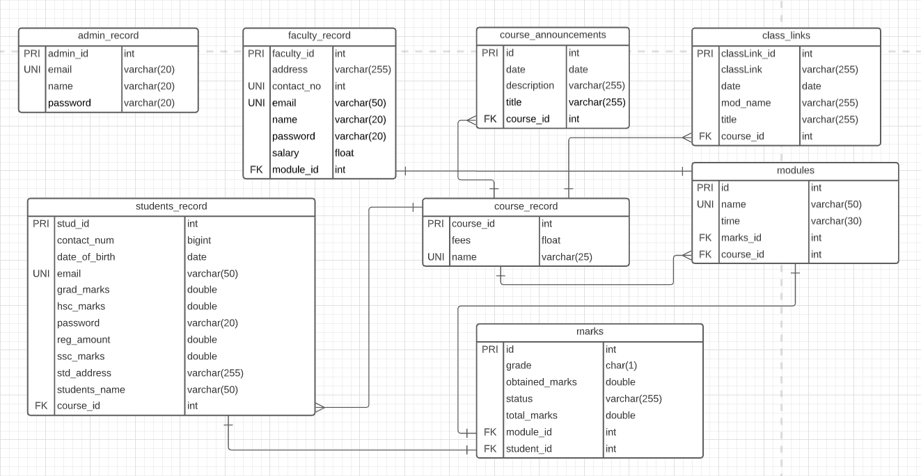

## 5.2 Database Tables:

## 

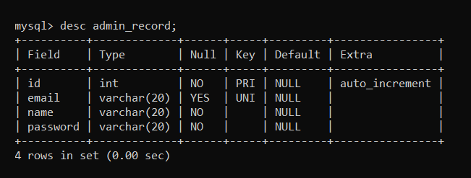

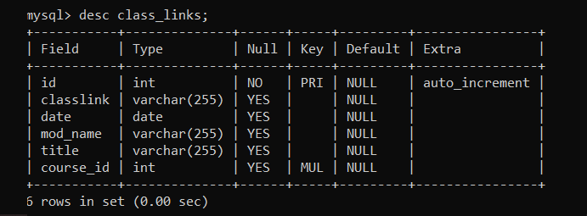

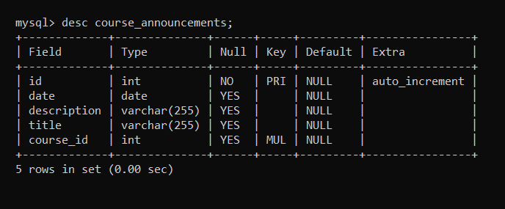

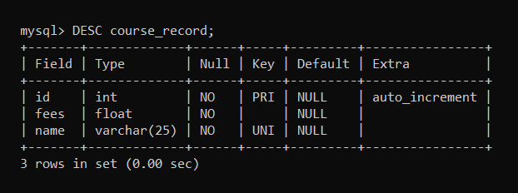

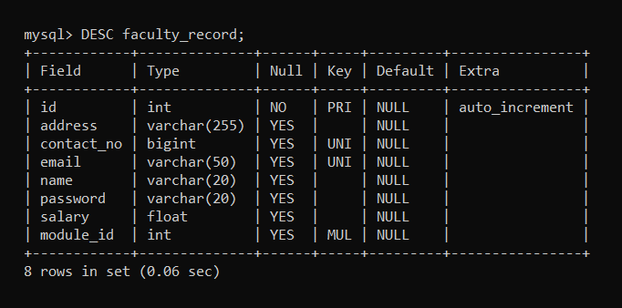

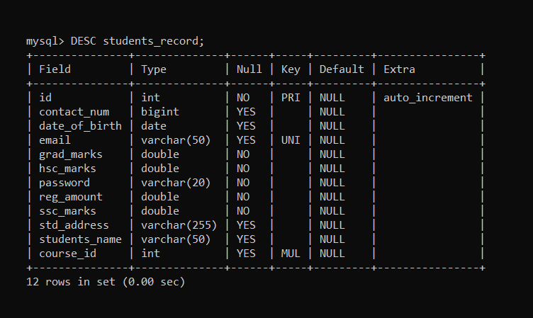

# Testing

**The report of the testing is given here under.**

**TEST CASES**

|  |  |  |
| --- | --- | --- |
| **Sr.No** | **Test CaseTitle** | **Result** |
| 1 | testAddAdmin() | Passed |
| 2 | testAddFaculty() | Passed |
| 3 | testAddAnnouncements() | Passed |
| 4 | linkAnnouncementsCourse() | Passed |
| 5 | testAddClassLink() | Passed |
| 6 | linkWithCourse() | Passed |
| 7 | testAddCourse() | Passed |
| 8 | testAddModule() | Passed |
| 9 | linkCourseModule() | Passed |
| 10 | linkFacultyModules() | Passed |
| 11 | testAddMarks() | Passed |
| 12 | linkMarksModules() | Passed |
| 13 | linkMarksStudents() | Passed |
| 14 | testAddStudent() | Passed |
| 15 | linkStudentCourse() | Passed |

# ProjectManagementMethodology

# 

Scrum Agile Methodology was used.

# 

# Future Updates

* 1. We will provide payment gateway to the registration formso that student can also pay through onlinemode.
  2. We will be adding more courses to the website so that it will give more options tothe student to select their favoritetraining program.
  3. We will also give the feedback form option in student home page.
  4. We will also add download option in list all assignment so that student can also download file.